Background Research (ROS2)

What is Robot Operating System (ROS)
- Robot operating system (ROS) is an open source robot operating system
- Originally developed in 2007 at the Stanford artificial Intelligence laboratory
- Since 2013 managed by OSRF (Open Source Robotics Foundation)
- It provides hardware abstraction, device drivers, libararies, visualisers, message-passing, package management, and more across multiple computers

ROS Characteristic
- Distributed computation: spans many different processes and runs across several different computers.
- Software reuse: growing collection of good algorithms for navigation, motion planning, mapping, and many others.
- Rapid testing: well-designed ROS systems separate the low-level control of the hardware, and high-level processing and decision making into separate programs.
- Widespread support: the critical mass of support makes it reasonable to predict that ROS will continue to evolve, expand, and improve.

ROS Ecosystem
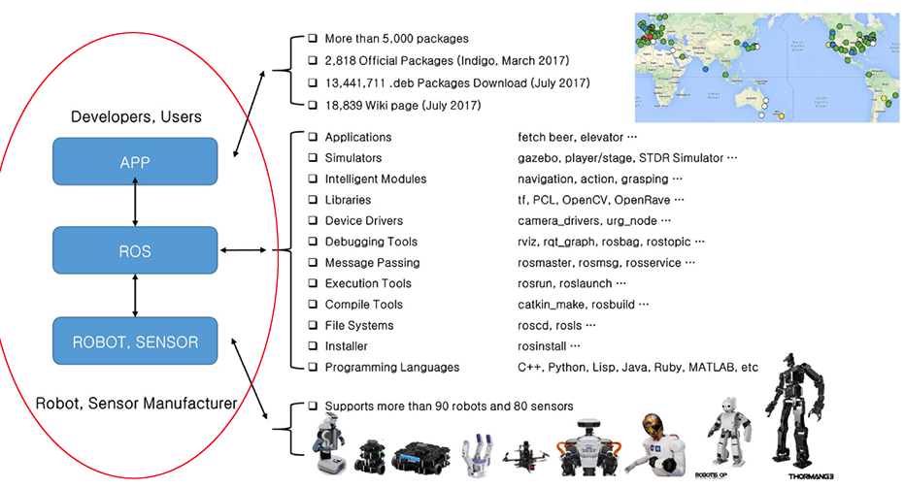

Two Sides of ROS
- The Operating System Side: Provides standard operating system service:
  - Hardware abstraction
  - Low-level device control
  - Implementation of commonly used functionality
  - Message-passing between processes
  - Package management
- The User Contributed side: Provide the package that implements common robot functionality, such as SLAM, planning, perception

ROS Main Features
- Modularity: A powerful way to handle that complexity
- Publication/Subscription: A common mechanism enables modularity environment
- Sensors and actuators are wrapped in self-contained, reusable software containers called “nodes”
- An Operating system such as Ubuntu(Used in the lab for linux) is required for ROS

ROS Packages
- All software files in ROS are organized in packages
- A package contains one or more nodes
- A package contains all source code files, configuration files, completion files, launch files, and parameter files
- All the files in a package are organized in a directory

ROS 2 Nodes
- The architecture of a ROS system consists of a few components: nodes (Publisher nodes or subscriber nodes), topics and services
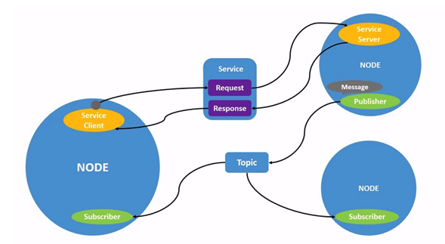

Nodes
- Nodes are the basic unit in ROS
- Single-purposed executable programs, such as sensors driver, actuator driver, mapper, planner, UI and so on.
- Nodes can communicate with each ither using topics or services
- Nodes can publish or subscribe to a Topic
- Nodes can also provide or use a Service
- Starting a node or Running a ROS Program
  - “Ros2 run package-name node-name”
- Listing the names of all the running nodes
  - “Ros2 node list”
- Inspecting a node to get a list of topic for which that node is a publisher or subscriber
  - "Ros2 node info node-name”

Differential Driving Robots
- A differential Driving robot can only move forward/backward and rotate only around its vertical axis
- The robot can’t move sideways
  - Thus, we only need to set the linear x component and the angular Z component in the “Twist” message
- An omni-directional robot would also use the linear y component while a flying or underwater robot would use all 6 components

Difference between move.linear vs move.angular
In robotics, move.linear refers to linear motion, which is motion in a straight line. move.angular refers to angular motion, which is motion around an axis. In terms of velocity command for the robot, move.linear is the velocity in a given direction and move.angular is the angular velocity around a given axis.

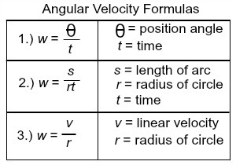

Difference between move.linear.x vs move.linear.y vs move.linear.z
In robotics and computer science, move.linear.x, move.linear.y, and move.linear.z are likely variables used to represent the linear velocity of a robot or object in the x, y, and z directions respectively. The x direction is typically associated with the width or horizontal direction, the y direction is associated with the height or vertical direction, and the z direction is associated with the depth or forward/backward direction. These variables can be used to control the movement of a robot or object in a three-dimensio6nal space.

Turtlesim- ROS Robot Simulation
- Turtleism is a ROS package which is used as a ROS robot simulator
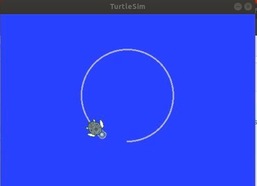
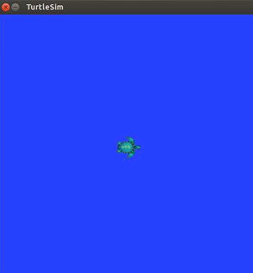
- The simulation consists of a graphical window that shows a turtle shaped robot
To move the turtle in a circle:
ros2 topic pub /turtle1/cmd_vel geometry_msgs/Twist "{linear: {x: 2.0, y: 0.0, z: 0.0}, angular: {x: 0.0, y: 0.0, z: 1.8}}"

To run turtlesim node, use
ros2 run
“turtlesim turtlesim_node”

- Using the rqt_graph tool to show node relationship and topics

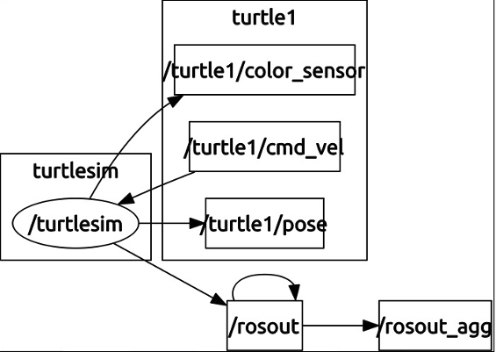

References
Gu, D. (2023, February). Robot Operating System Tutorial. Robotics. Colchester; 1N1.2.1A.
Gu, D. (2023, February). Proprioceptive sensors and Odometry. Robotics. Colchester; 1N1.2.1A.

